
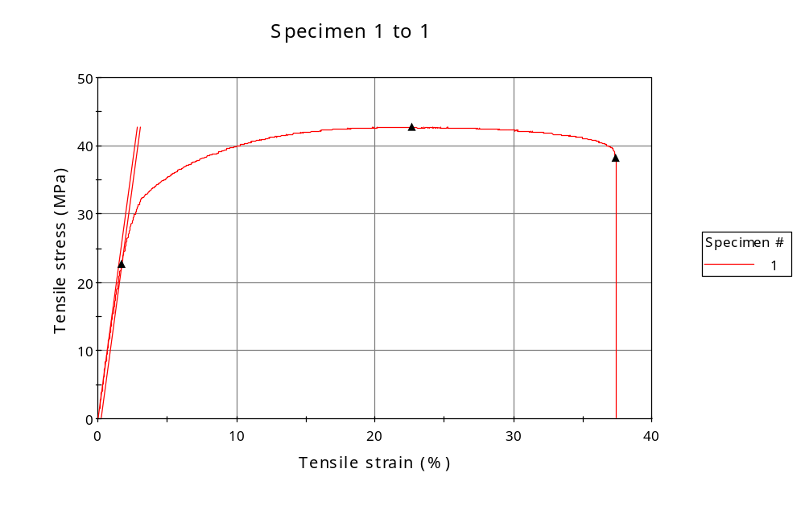
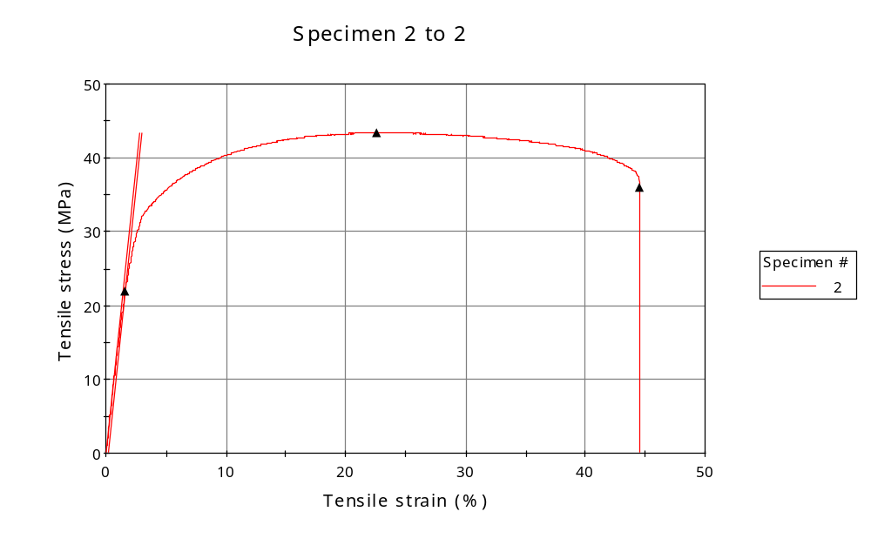
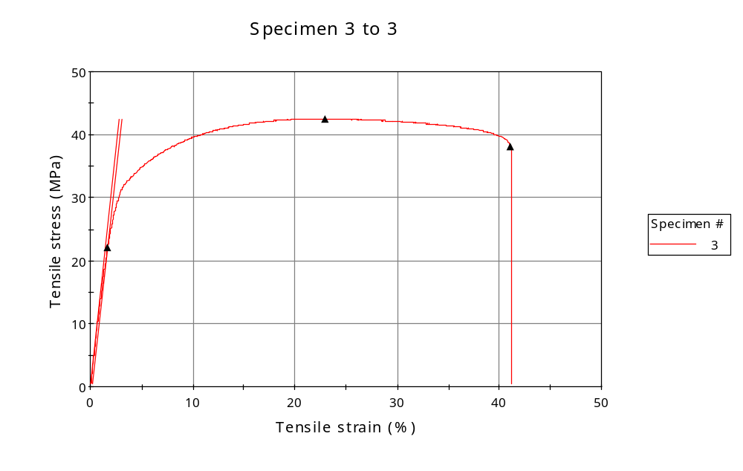
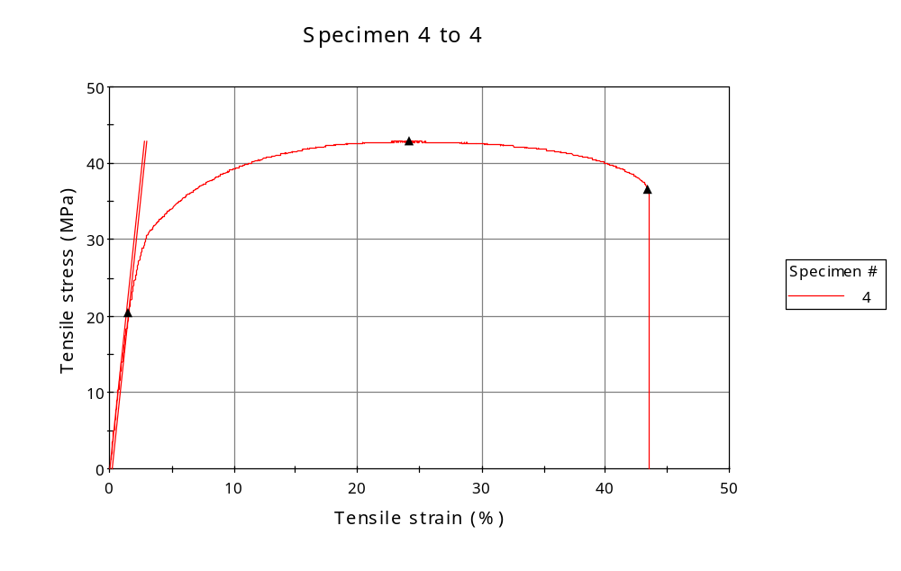
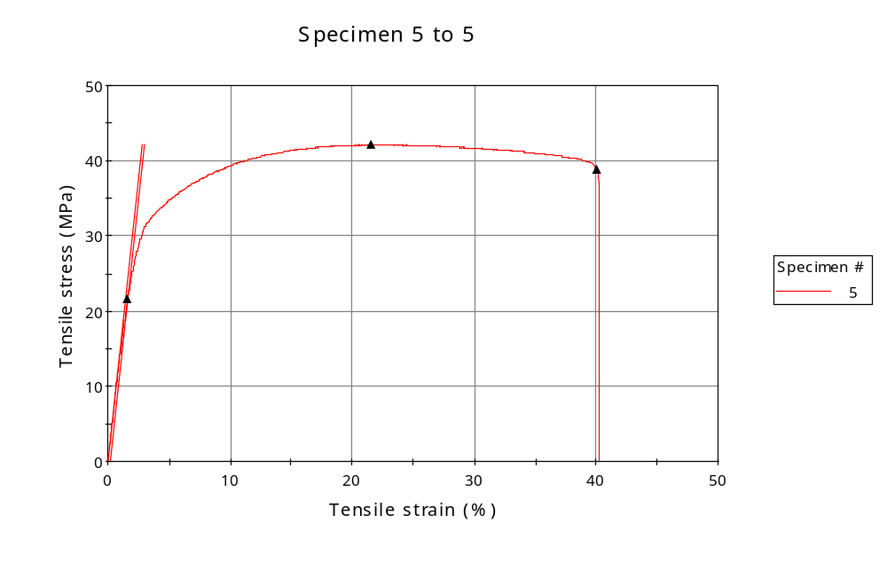
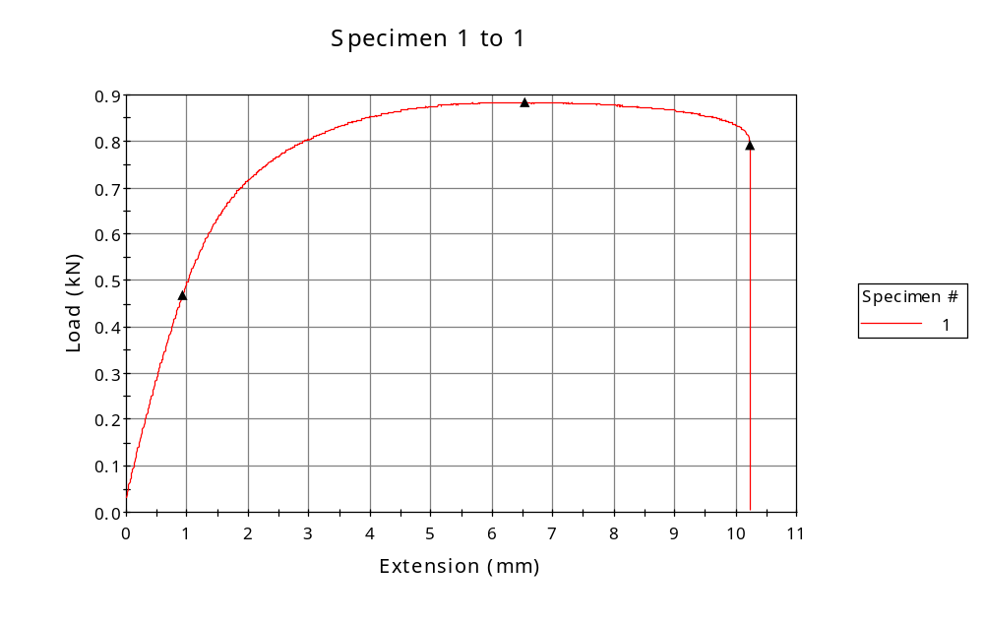
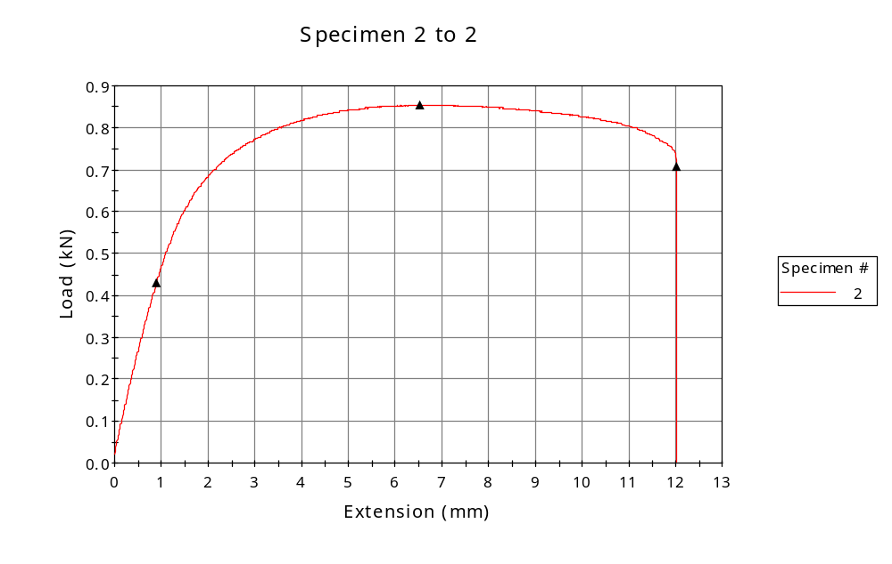
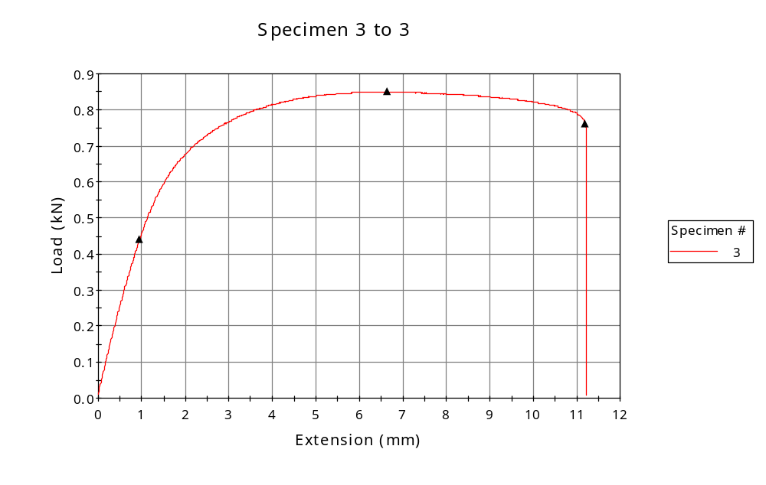
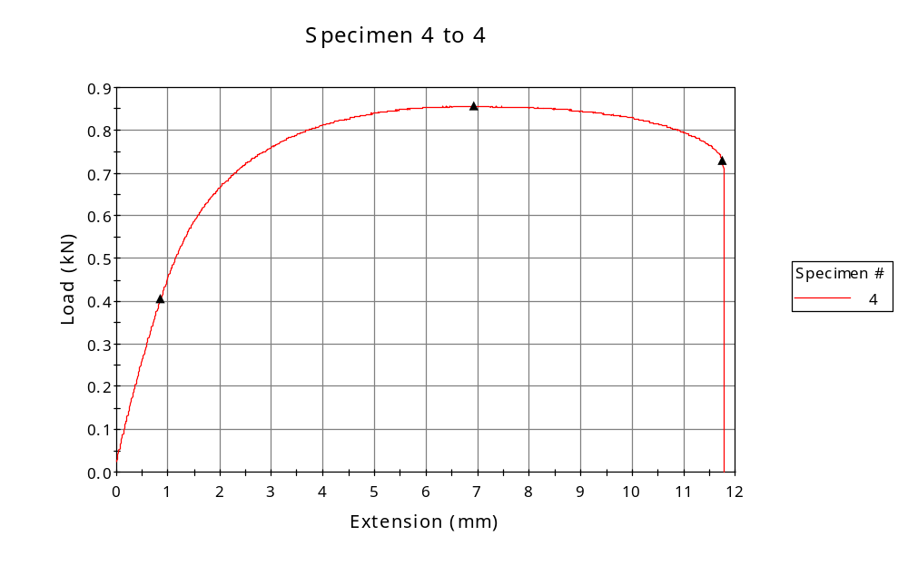
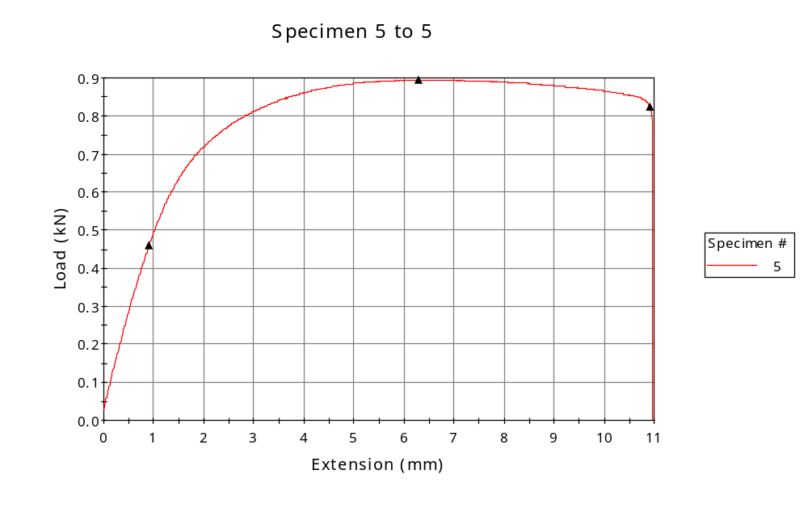

 | CP ID | Length  (mm) | Width  (mm) | Thickness  (mm) | Modulus (Automatic Young's)  (MPa)
1 | CP-01 | 25.00 | 6.05 | 3.42 | 1520
2 | CP-02 | 25.00 | 6.00 | 3.28 | 1576
3 | CP-03 | 25.00 | 6.02 | 3.32 | 1502
4 | CP-04 | 25.00 | 6.02 | 3.32 | 1533
5 | CP-01 | 25.00 | 6.02 | 3.53 | 1534
Maximum |  | 25.00 | 6.05 | 3.53 | 1576
Minimum |  | 25.00 | 6.00 | 3.28 | 1502

 | Load at Fy ( 0.2 %) - LE  (kN) | Tensao em Fy ( 0.2 %) - LE  (MPa) | Deformacao em Fy ( 0.2 %) - LE  (%) | Forca Max  (kN) | Tensao na Forca Max - LR  (MPa)
1 | 0.469 | 23 | 1.695 | 0.885 | 43
2 | 0.431 | 22 | 1.594 | 0.854 | 43
3 | 0.439 | 22 | 1.660 | 0.850 | 43
4 | 0.406 | 20 | 1.531 | 0.857 | 43
5 | 0.459 | 22 | 1.603 | 0.895 | 42
Maximum | 0.469 | 23 | 1.695 | 0.895 | 43
Minimum | 0.406 | 20 | 1.531 | 0.850 | 42

 | Deformacao na Forca Max - LR  (%) | Forca na Forca na Quebra - LQ  (kN) | Deformacao na Forca na Quebra - LQ  (%)
1 | 22.656 | 0.791 | 37.389
2 | 22.576 | 0.706 | 44.510
3 | 22.909 | 0.761 | 41.110
4 | 24.143 | 0.729 | 43.410
5 | 21.604 | 0.823 | 40.038
Maximum | 24.143 | 0.823 | 44.510
Minimum | 21.604 | 0.706 | 37.389

